**ASSIGNMENT**

**MODULE 3**

**IAM USERS**

**DONE BY**

**RANJITH KUMAR**

**Problem Statement:**

You work for XYZ Corporation . To maintain the security of the AWS account and the resources you have been asked to implement a solution that can help easily recognize and monitor the different users.

**Tasks To Be Performed:**

1. Create 4 IAM users named “Dev1”, “Dev2”, “Test1”, and “Test2”.

2. Create 2 groups named “Dev Team” and “Ops Team”.

3. Add Dev1 and Dev2 to the Dev Team.

4. Add Dev1, Test1 and Test2 to the Ops Team.

1. **Create 4 IAM users named “Dev1”, “Dev2”, “Test1”, and “Test2”.**

**TASK 1:**

**Step 1 :** Select IAM from the aws sevices

**Step 2** : In Access Management select users

**Step 3** : In Users page click **“Add user”**

**Step 4 :** In the user details give name to the users . select “user access to the AWS Management Console” and click “I want to create an IAM user” to give **console access to a user.**

**Step 5** : In user details ,on the console password we can autogenrate password or customize passwords as of our requirements . User can also change password at next sign in of iam user if the checkb is selectedbox

(I have choosen custom password and unchecked- “Users must create a new password at next sign-in – Recommended”)

**Step 6** : In Permission option page select > Add user to group

**Step 7** : In the Review and Create page we can see the details given in previous page . Then

Click Create User

**Step 8** : In Retrieve password page details of URL , user name and password .By downloading .csv file we can see our login credentials.

(**I have repeated the above steps for creating other users**)

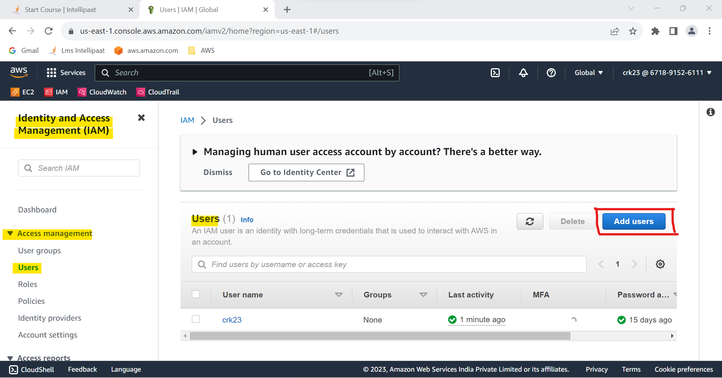

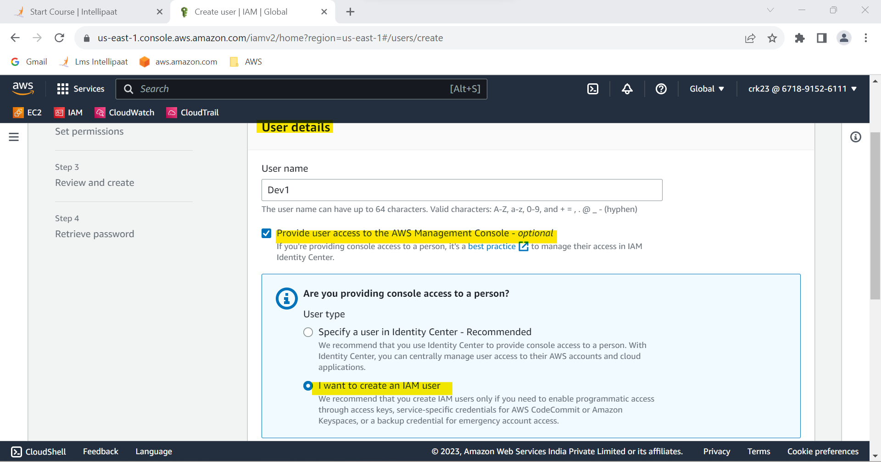

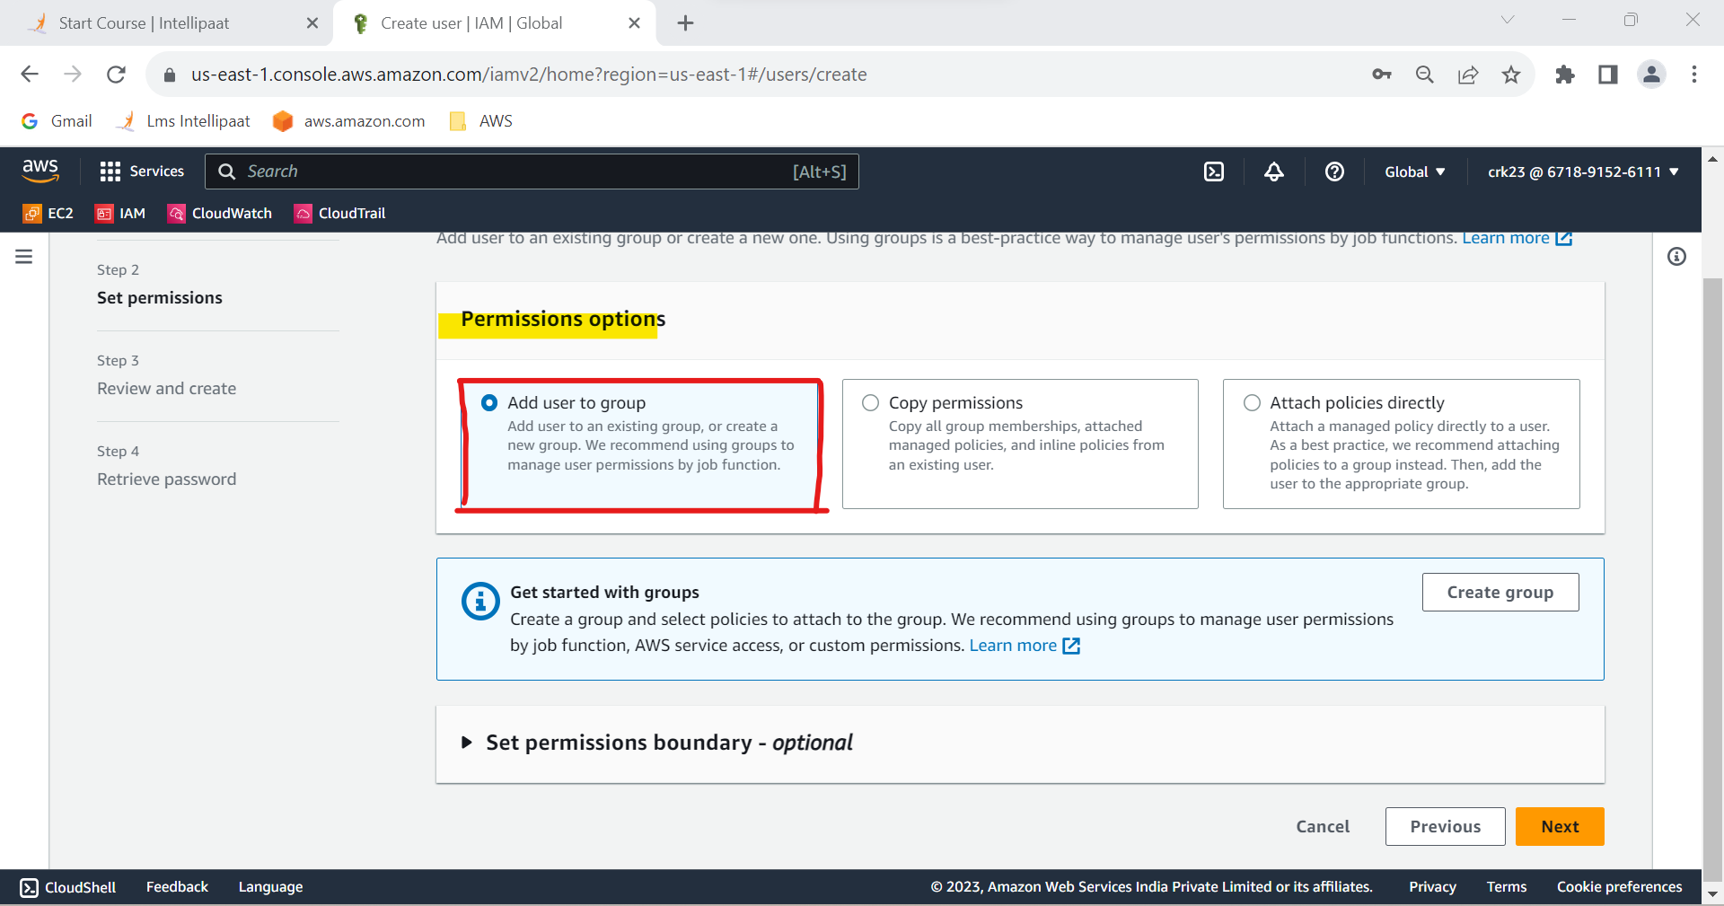

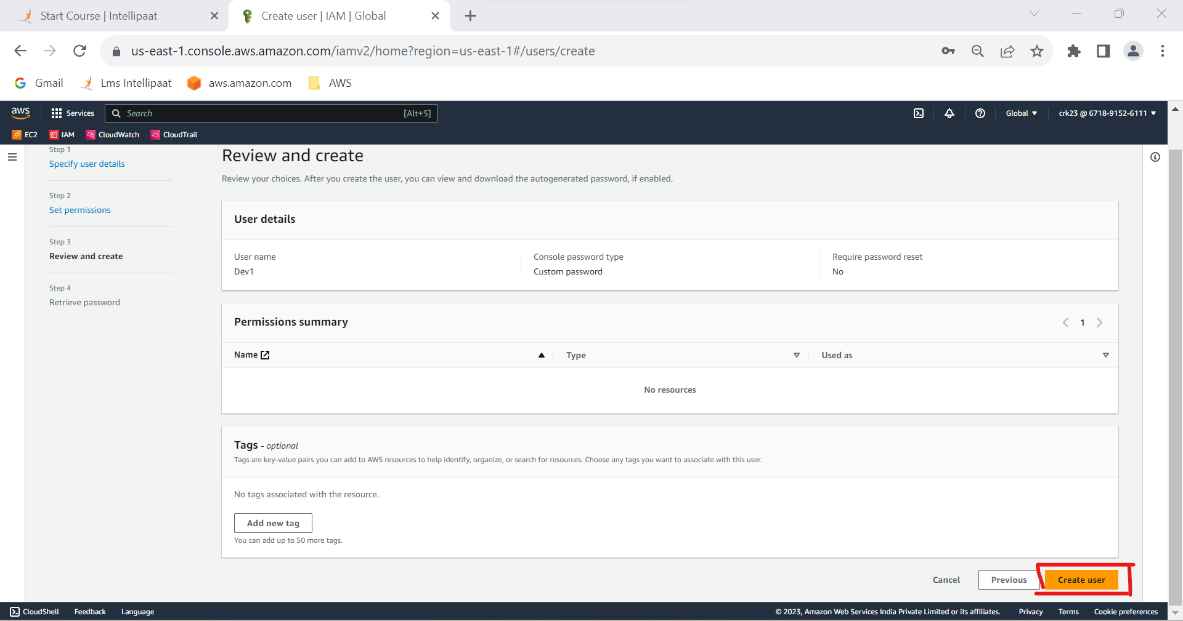

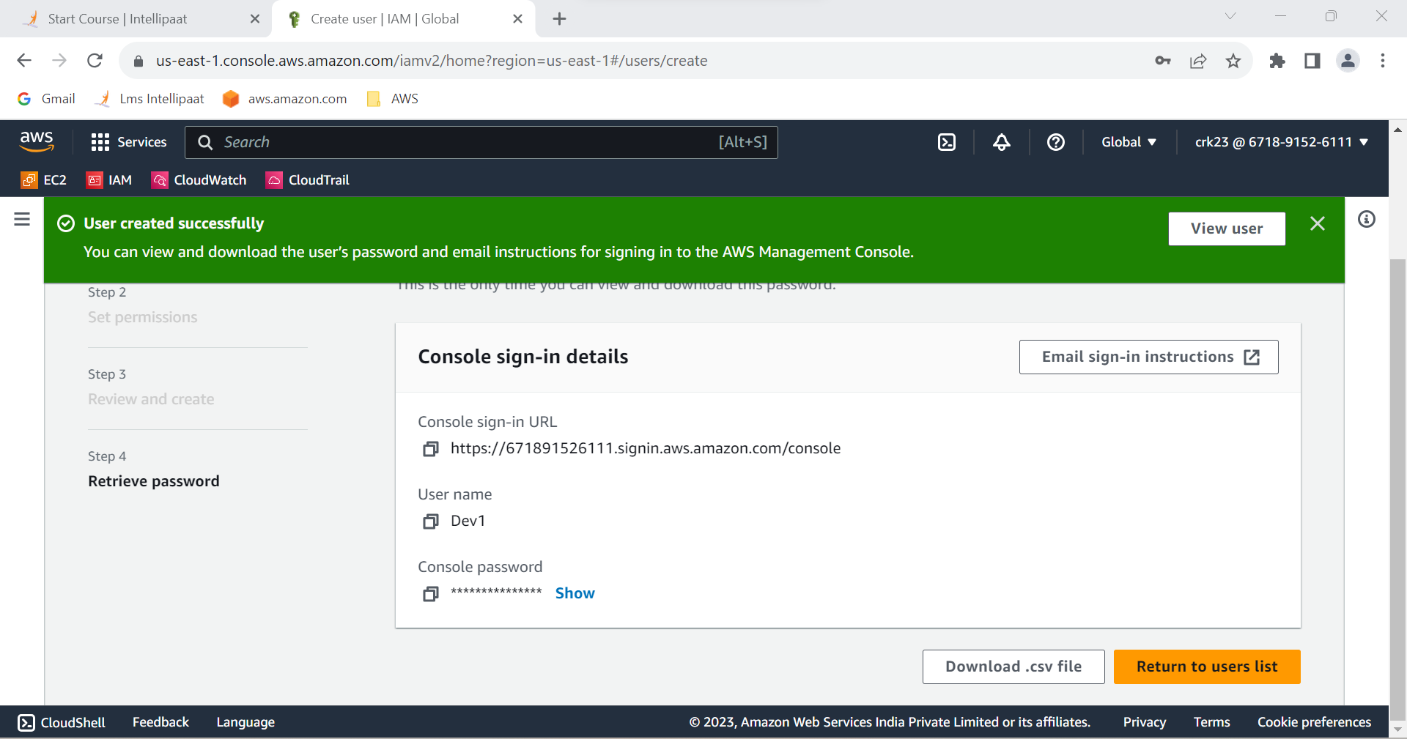

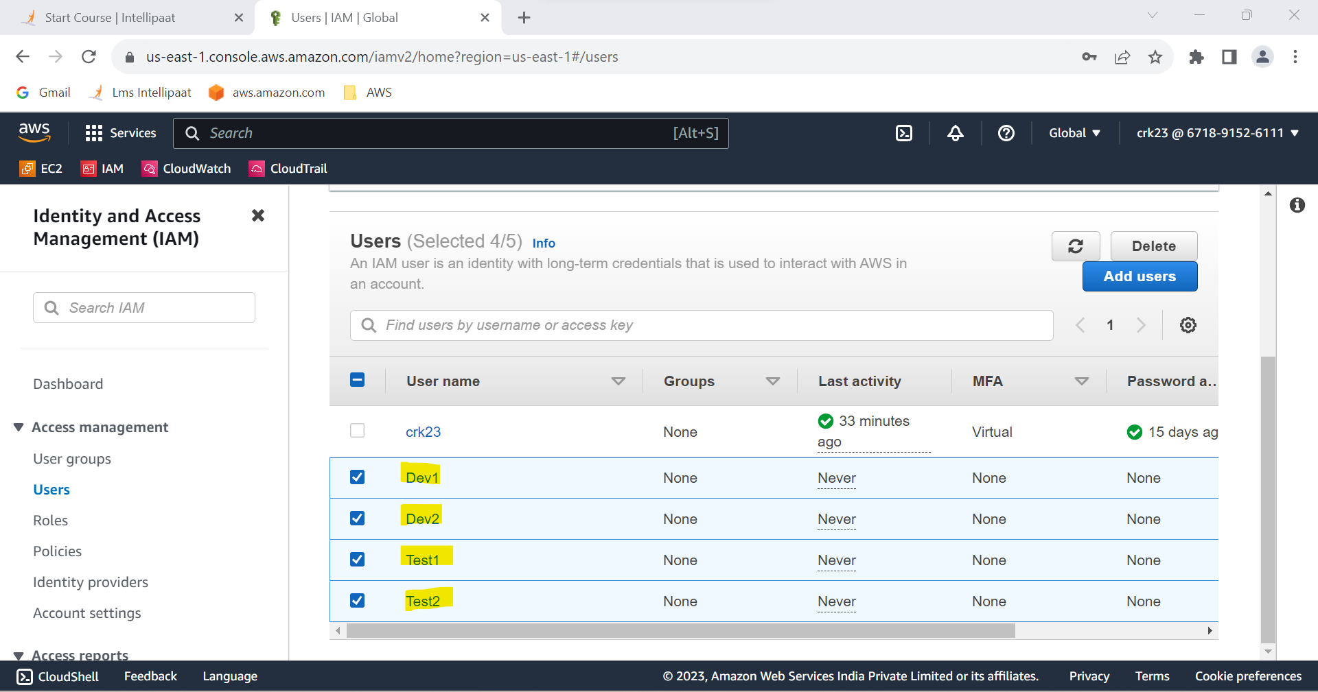

**Task 1 Output :**

4 IAM users named “Dev1”, “Dev2”, “Test1”, and “Test2” have been created.

**2. Create 2 groups named “Dev Team” and “Ops Team”.**

**Step 1** : In Acess management select User groups

**Step 2** : In user groups select Create groups

**Step 3** : Give name to the group and click create group.

**(I have repeated above steps to create “Ops_team” group)**

**Step 5** : Groups hase be created

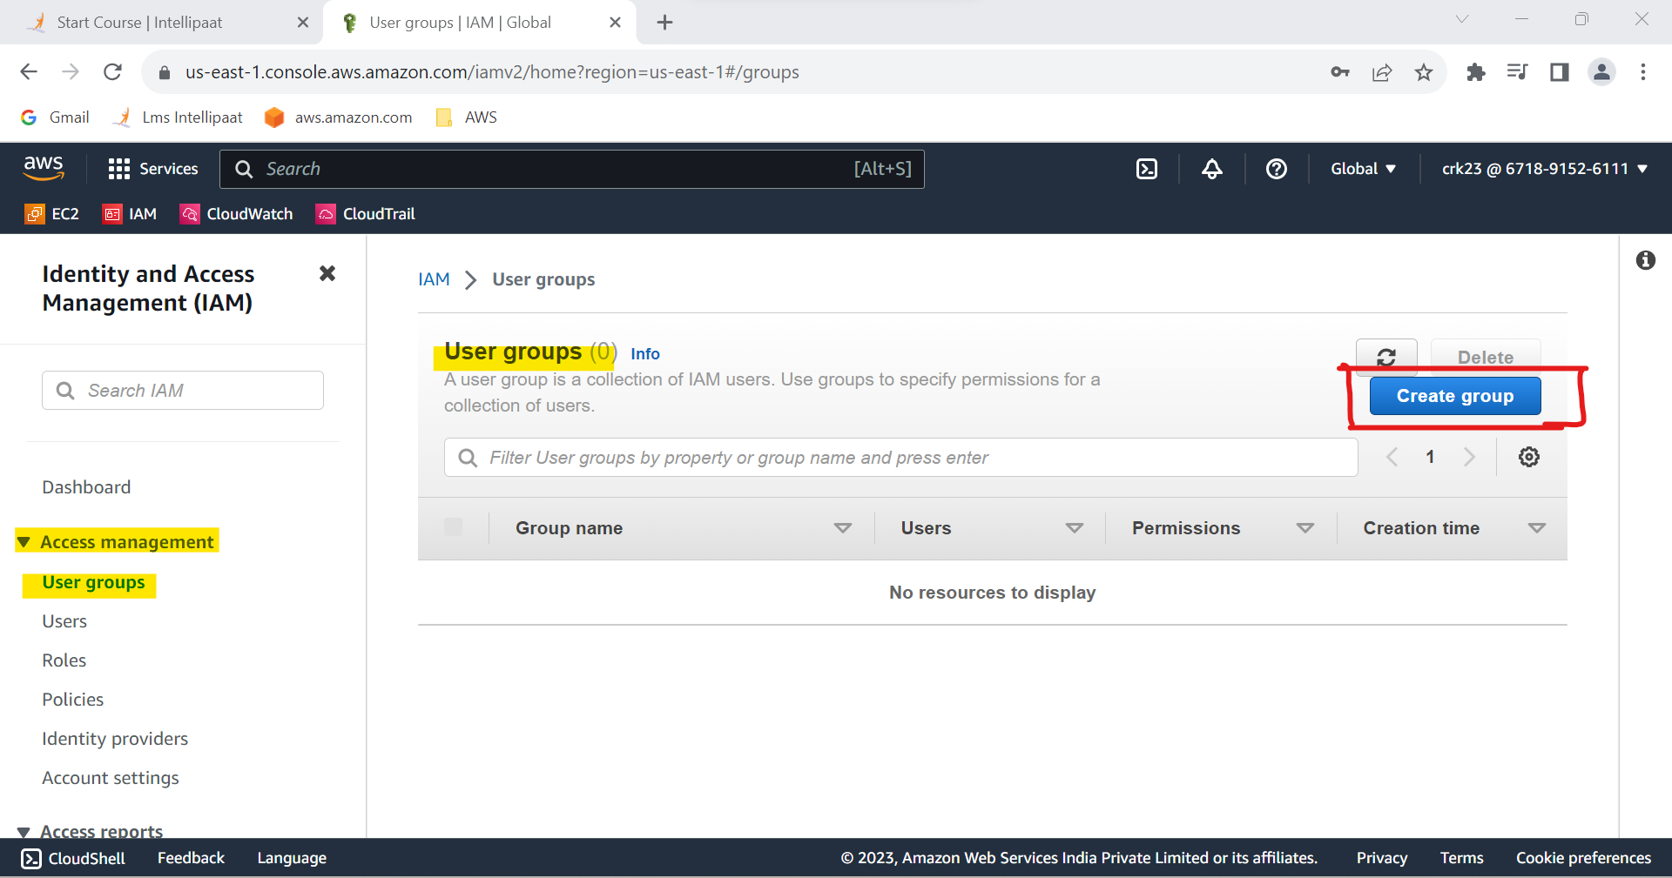

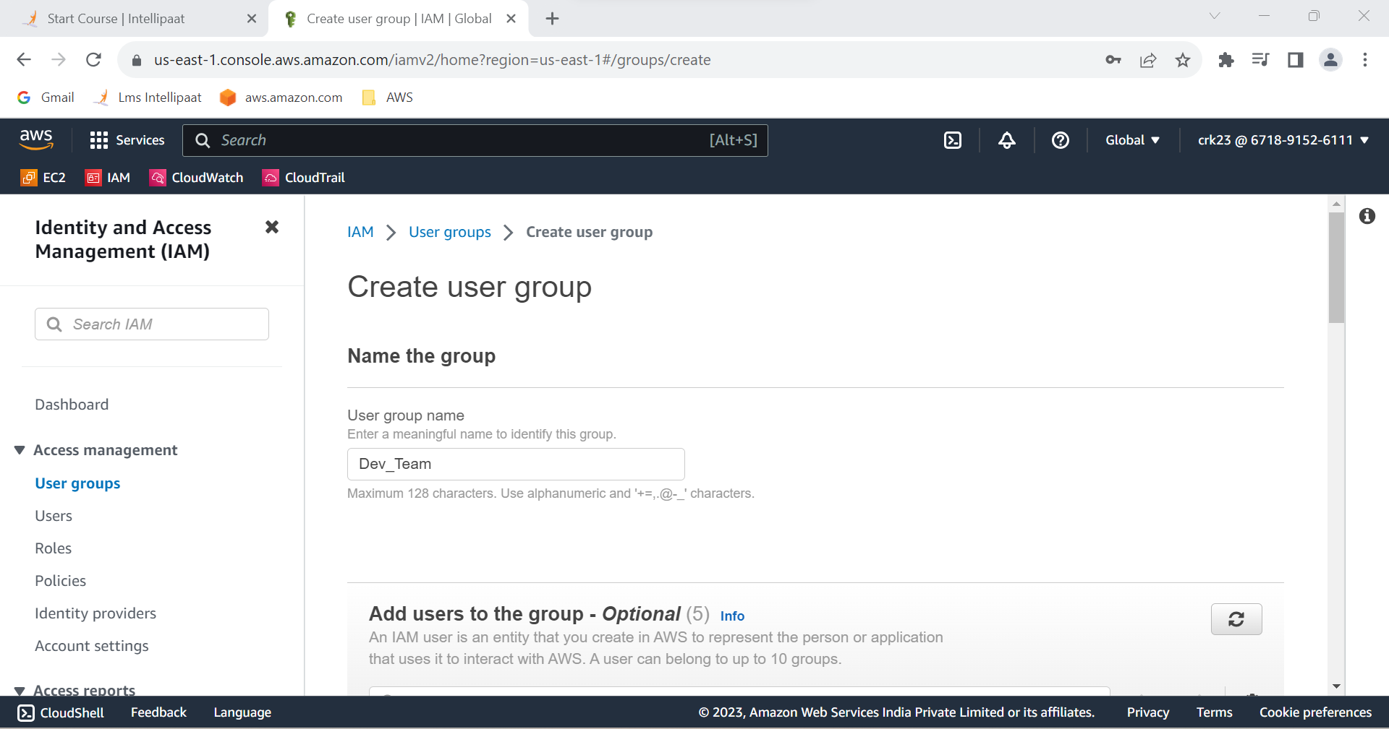

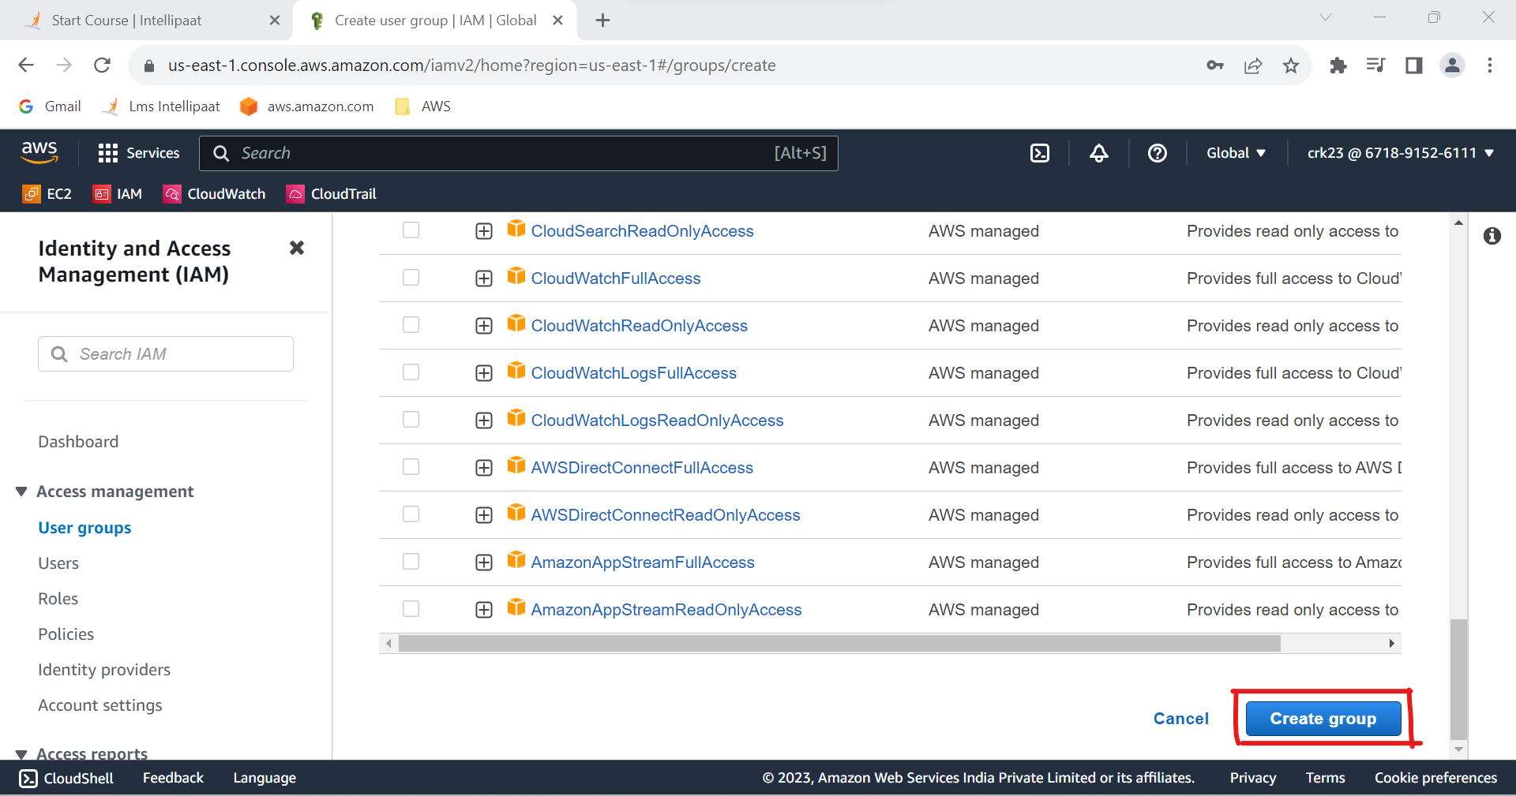

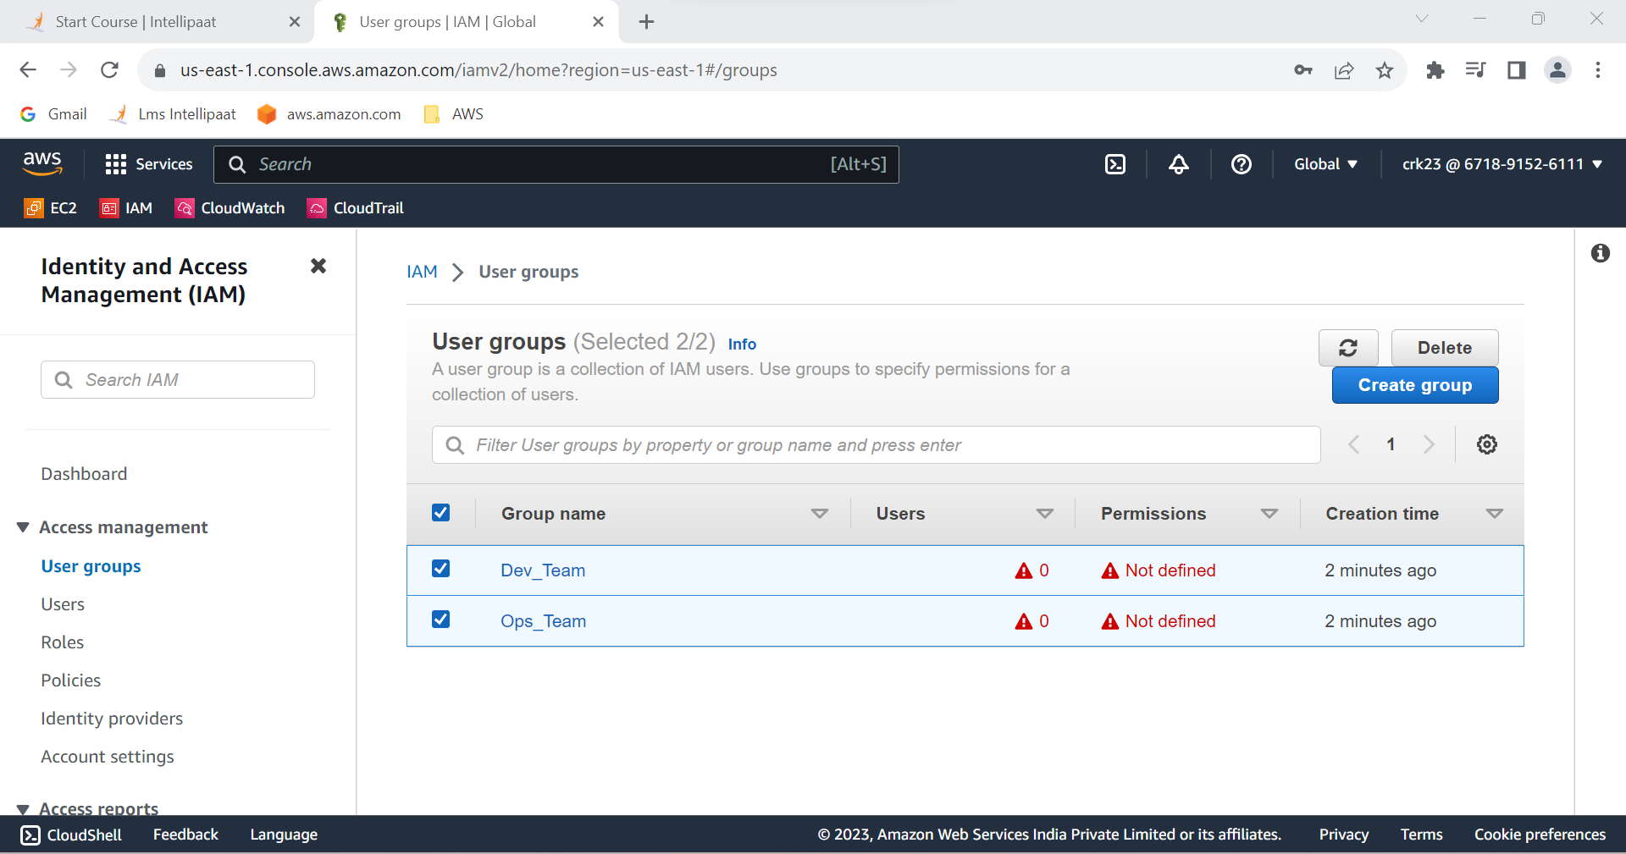

**Task 2 Output :**

2 groups named “Dev Team” and “Ops Team” have been created .

**3. Add Dev1 and Dev2 to the Dev Team.**

**Step 1:** Select User groups in acess mangament

**Step 2** : Select the Dev_Team

**Step 3** : In user tab select add users

**Step 4** : Add Dev1 & Dev2 to the Dev group

**Step 5** : Dev1&Dev2 are add to the Dev Team

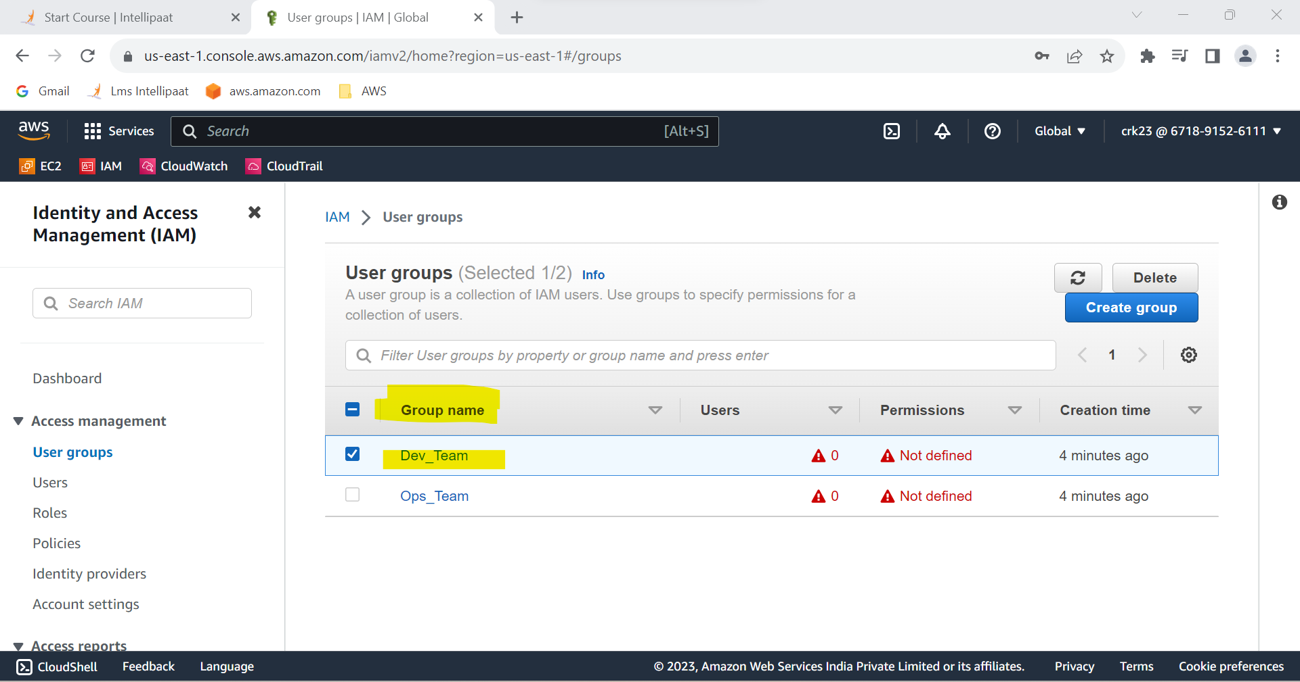

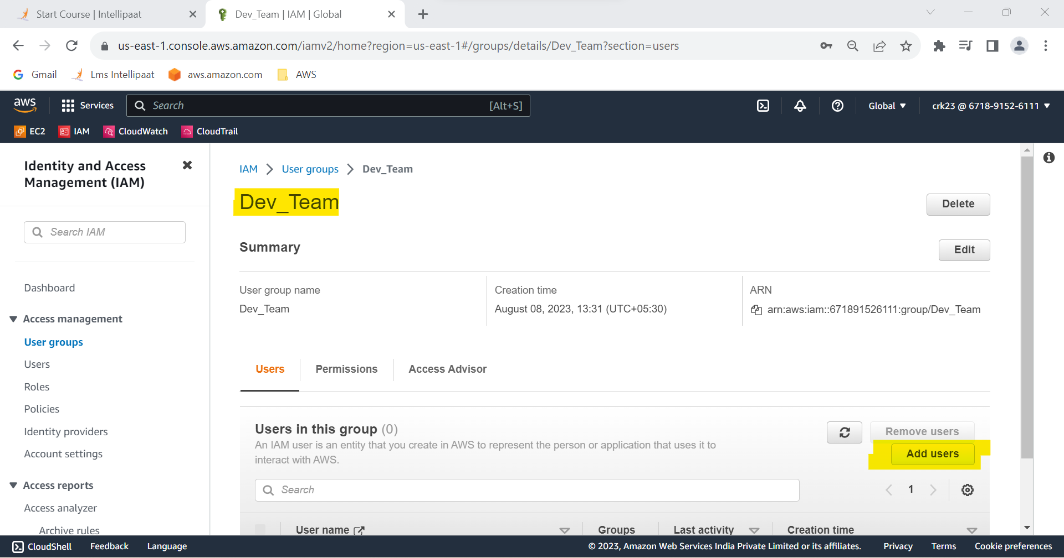

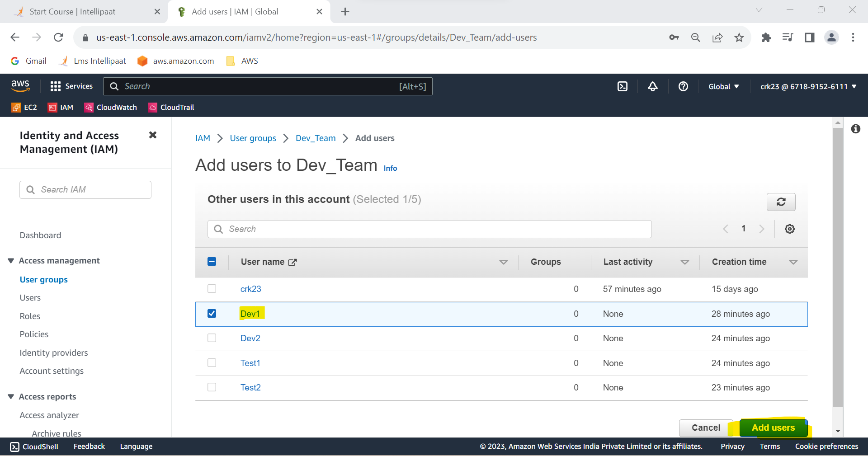

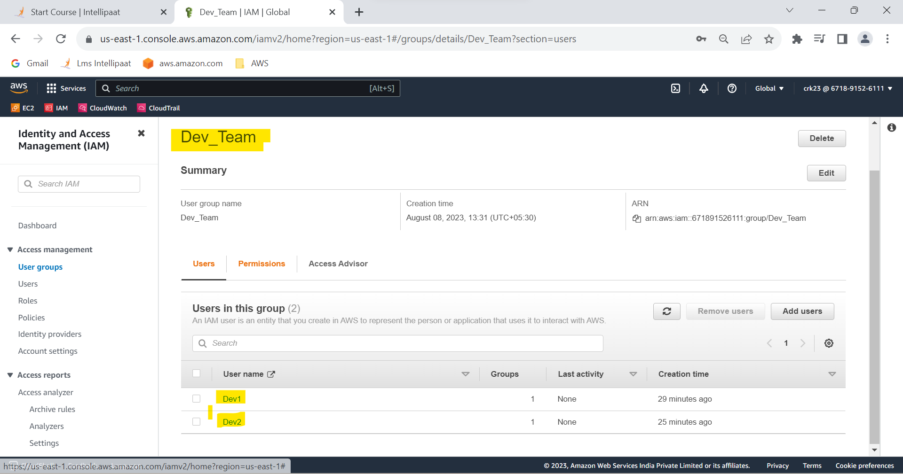**`**

**Task 3 Output :**

Dev1 and Dev2 are added to the Dev Team.

**4.Add Dev1, Test1 and Test2 to the Ops Team.**

**Step 1:** Select User groups in acess mangament

**Step 2** : Select the Ops_Team

**Step 3** : In user tabs select add users

**Step 4** : Add Dev1,Test1 & Test2 to the Ops group

**Step 5** : Dev1, Test1 & Test2 are add to the Ops Team

